T.C.
BAHÇEŞEHİR UNIVERSITY



FACULTY OF ENGINEERING AND NATURAL SCIENCES

eTHical and bias awarness auditing tool

Rama Al-Tamimi – Artifical intelligence

Advisors: Murat Goksin Bakir

STUDENT DECLARATION

By submitting this report, as partial fulfillment of the requirements of the Capstone course, the students promise on penalty of failure of the course that
- they have given credit to and declared (by citation), any work that is not their own (e.g. parts of the report that is copied/pasted from the Internet, design or construction performed by another person, etc.);
- they have not received unpermitted aid for the project design, construction, report or presentation;
- they have not falsely assigned credit for work to another student in the group, and not take credit for work done by another student in the group.

ABSTRACT
Ethical and bias awarness auditing tool

Rama Al-Tamimi 2285460

Faculty of Engineering and Natural Sciences

Advisor: Murat Goksin Bakir

May 2021

This project introduces an Ethical and Bias Aware AI Auditing Tool that can efficintly use machine learning algorithms to detect questionable discriminative practices, hidden biases, and ensure fairness in the models. Typical auditing tools are non user friendly, require very deep technical knowledge of the user, or often address only limited fairness aspects.
The proposed system will integrate three major modules: a Data Analysis Module, a Fairness Evaluation Module, and a Bias Reporting Module. These modules altogether analyze datasets and model outputs to detect potential biases and assess ethical risks, thus giving practical recommendations for improvement. Such a system should also provide support for both technical and nontechnical users via a userfriendly dashboard and visual fairness summaries with automatic report generation. By integrating statistical fairness checking with ethical guidelines, this tool enables responsible AI auditing in a way that is both accessible and comprehensive.

Key Words: ML, Fairness, Ethical.

TABLE OF CONTENTS
ABSTRACT iii
TABLE OF CONTENTS iv
LIST OF TABLES v
LIST OF FIGURES v
LIST OF ABBREVIATIONS vi
1. OVERVIEW 1
1.1. Identification of the need 1
1.2. Definition of the problem 1
1.3. Conceptual solutions 2
1.4. Physical architecture 4
2. WORK PLAN 6
2.1. Work Breakdown Structure (WBS) 6
2.2. Responsibility Matrix (RM) 6
2.3. Project Network (PN) 7
2.4. Gantt chart 7
2.5. Risk assessment 8
2.6. Dataset & Preprocessing..............................................................................................9
2.7. Model Development....................................................................................................9
2.8. Metheodology............................................................................................................10
2.9. System Development.................................................................................................10
2.10. Unit Testing.............................................................................................................11
2.11 Risk Management.....................................................................................................11
2.12 Ethical Considerations..............................................................................................12
2.12 Deployment Strategy................................................................................................12
3. SUB-SYSTEMS 13
3.1. The name of the sub-system 1 13
3.2. The name of the sub-system 2 13
4. INTEGRATION AND EVALUATION 15
4.1. Integration 15
4.2. Evaluation 16
5. SUMMARY AND CONCLUSION 17
6. HOW TO RUN......................................................................................................................18
REFERENCES 19
APPENDIX A 21

LIST OF TABLES
Table 1. Conceptual Workflow and Modules. 2
Table 2. Responsibility Matrix for the team 6
Table 3. Work breakdown structure for the project. 6
Table 4. Gantt chart for the materialisation phase of the project. 7
Table 5. Risk assessment 11

LIST OF FIGURES

Figure 1. System Archeticture Design 4
Figure 2. The project network. 7

LIST OF ABBREVIATIONS
AI Artificial Intelligence
ML Machine Learning
IEEE The Institute of Electrical and Electronics Engineers

1. OVERVIEW
Demo video with explanation: https://youtu.be/7k5xnhaEUsM

1.1. Identification of the need

AI systems increasingly impact critical decisions, yet biases and discrimination persist in datasets and models. Transparent auditing is needed for regulatory and ethical compliance. Despite AI’s continuously growing and expanding into more fields, most businesses don’t have access to bias checking models and those who do have it in their possession, their models often require deep knowledge of ML in order to understand or may simply not work all model types. Such a model would be helpful to double check accountability and ensure fairness is always implemented.

1.2. Definition of the problem
The challenge lies in creating quantitative fairness metrics and visual tools that detect bias while remaining model-agnostic and interpretable for non-technical stakeholders. Alot of AI models unintentionally develop biases from the same datasets they were trained on and often it goes unnoticed by the developers. At the same time, the models that already exist that are capable of recognising those biased decision making patterns are targeted only for the experts in this field making it difficult to use by others. The goal is to create a system that maintains ethical fairness while remaining simple enough to understand and interpret.

1.2.1. Functional requirements
- The system should support uploading the dataset used for evaluation along with the trained machine learning model without requiring any retraining.
- The system must calculate the required fairness measurements in order to determine whether the model gives similar results or biased results to different groups of people or data.
- The model must be capable of generating visualizations to demonstrate the results in a clear and easy to understand format.
- The system should be able to handle and work with different model formats.
- The system must be simple enough to give non-technical users the opportunity to navigate, explore and view the results easy.
- The system must provide the users with summaries of the results to simplify the user’s experience and make it more accessible.

1.2.2. Performance requirements
- The system must be able to calculate the fairness metrics and generate the results in a reasonable time despite the dataset’s size.
- Visualizations should be generated smoothly without crashes or long-time delays.
- The system must be able to process the datasets without taking up too much memory.
- The system’s results must be consistent; the same model with the same dataset should always give out the same results for the fairness measurements.
- The model must work smoothly and remain responsive for users.

1.2.3. Constraints
- Economic Impact: The tool mitigates the economic constraint of a high cost of compliance. With this tool, since it is an open-source and automated system for auditing, one will not have to pay much for any proprietary system, thereby having free AI safety.
- Environment Impact: It follows the principles of "Green AI," as it minimizes the consumption of computational energy. Unlike the cloud solution for the audit software, the software does not need servers to operate all the time. It does not involve the transfer of a lot of data as well. The software only performs the inference phase and not the training phase of the model.
- Social Impact: There’s a lack of accountability in algorithms. The proposed solution addresses this issue by being a direct counter to biased automation, as it is capable of pointing to potential fairness problems in critical application areas such as the job market or finance. By allowing its users to understand the code through SHAP/LIME explanations, it gives non-coders, such as social workers, the ability to audit AI.

1.3. Conceptual solutions
The “Ethical and Bias-Aware AI Auditing” tool’s purpose is to provide support for users in detecting, understanding and addressing the bias present in some AI models. Each component in this project serves a unique purpose towards the goal of creating an accurate and accessible model that ensures ethical fairness. In table 1.1 “Conceptual Workflow and Modules” a summary of the model’s main components, their purpose, and what contributions do they add to the model to make it more accessible for everyone are listed accordingly.
Module | Component | Purpose | Contribution
Data Analysis Module | Preprocess dataset | Ensures datasets are clean and consistent | Helps avoid errros in future tasks
 | Input dataset & model | Accepts datasets and models for evaluation | Allows the uploading of multiple AI formats.
Fairness Evaluation Module | Fairness Evaluation Model | Calculates fairness metrics | Identifies bias among subgroups if present
Bias Reporting Module | Visualization Layer | Generates visualized results | Provides easy to internpret results for all users
 | Summary Report Generator | Generates summaries of results | Provides concise explanantions
Table 1.1 Conceptual Workflow and Modules

1.3.1. Literature Review
The increasing rate of artificial intelligence adoption into high-stakes domains, such as hiring, lending, and criminal justice, has forced a corresponding development of robust frameworks for algorithmic accountability. In turn, several open-sourced toolkits have been developed to measure and mitigate bias. In practice, a review of the current landscape indicated a large gap between technical capability and accessibility by non-expert stakeholders.
The most known tool in this space is AI Fairness 360 from IBM, or AIF360. It was published in 2018 and since then it has become a complete open source library with more than 70 fairness metrics and several bias mitigation algorithms. [1]. Although it is powerful for engineers, AIF360 is actually targeted at data scientists: significant programming experience in Python is required to apply it, and an out-of-the-box graphical user interface (GUI) for non-coders is not available.
On the other hand, the Microsoft Fairlearn library emphasizes the study of harm associated with fairness and has algorithms for mitigation, such as the "Exponentiated Gradient Reduction" approach [2]. The visualization tools are often linked with Jupyter Notebook environments and fairness ML algorithms are well integrated with Azure. In reality, these can scare off the legal compliance officers or the business managers if they do not have much exposure to programming environments.
While it is true that powerful toolsets exist for detecting bias, there is still a research gap. Most tools in this area function as libraries for coding, involving complicated installation procedures or cloud services. Moreover, there is currently little research software available to integrate fairness (such as Demographic Parity) with explanation (such as LIME) in one local interface for non-experts [3].
The Ethical and Bias Awareness Tool, which has been implemented in the project, tackles such shortcomings. Unlike AIF360 or Fairlearn, which are code first libraries, it functions as a local web application (Streamlit). It weaves together the complexity of Python code into an friendly interface where users can easily upload files and immediately obtain results in plain text format. In addition, by running on localhost rather than on the web cloud, it tackles the issues concerning data privacy that are normally overlooked by web applications that audit.

1.4. Physical architecture
The proposed system has at its core three modules: a Data Analysis Module, a Fairness Evaluation Module, and a Bias Reporting Module, all integrated in a centralized auditing dashboard. The system takes training dataset samples, model prediction outputs, and basic demographic atributes if available as input, and produces three outputs: a data quality overview, a fairness evaluation, and a simple bias report with recommendations. A simplified processing flow is presented below.
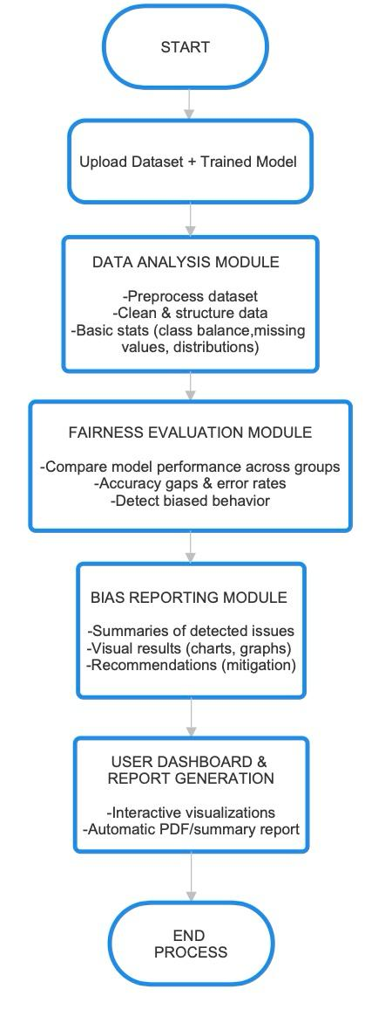
Figure 1.1 System Archeticture Diagram

Information regarding AI models, such as sample predictions, the dataset used for either training or testing, and relevant feature attributes, is input into the system. The data should undergo cleaning, standardization, and checks for consistency in formating to ensure that the auditing process is reliable. The cleaned data is then passed on to the Data Analysis Module for processing.
Data Analysis Module; The initial analysis of the dataset and model outputs is done by the Data Analysis Module. It calculates simple statistics on items like class distribution, missing value rates, and overall model accuracy. The module detects potential problems like highly imbalanced data or irregular distributions of features that may affect model behavior. This early set of indicators helps to set a baseline understanding of the AI system. At the same time, cleaned data is passed to the Fairness Evaluation Module, responsible for detecting various forms of disparities in model performance across groups. Using simple statistial comparisons, the module measures accuracy gaps, error rates, and prediction differences between demographic or feature-based groups. These then point toward whether the model behaves inconsistently or shows some evidence of possible bias.
The Bias Reportig Module is activated by the system, based on various findings coming from the other modules. This module summarizes the issues detected in a very clear and accessible way: with short explanations, visual indicators, and pratical recommendations like gathering more data, adjusting model thresholds, or reviewing the features used for training. It should present actionable guidance without requiring deep technical expertise.

2. WORK PLAN

2.1. Work Breakdown Structure (WBS)
Collection of the Ai models output and datasets, preprocessing and preparing the data | Clean and structured input dataset | Week 1
Applying fairness evaluation to check the models’ balanced results | Analysis report and fairness metrics | Week 2
Development of Explainability Logic (SHAP/LIME) | AI Behavior Check | Week 3
Identifies bias among subgroups if present and demonstrates it | Bias Reporting Module | Week 4-6
Building the dashboard that displays a chart that shows ethical results | Interactive visualization dashboard | Week 7
Developing a tool for automatic report summaries | Automated Risk Summary Generation | Week 8
Merge all the modules and test the system to ensure everything is perfect | Integrated and tested system | Week 9
Final documentation and presentation of project | Final report and presentation | Week 10
Figure 2.1 Work Breakdown Structure (WBS)

2.2. Responsibility Matrix (RM)
The Responsibility Matrix (RM) articulates the responsibilities of every team member during the entire project duration. Each team member contributed based on his/her technical strengths and project topic areas of focus. The project tasks were allocated with a balance of team collaboration and individual ownership of core project components.

Task / Module | Joud Wardeh | Rama Al-Tamimi | Halit barboti
Dataset collection & preprocessing | ✔
Fairness metric calculation | ✔ | ✔
Core system architecture |  | ✔
Backend module implementation |  | ✔
Dashboard & visualizations |  | ✔
Bias reporting & summaries |  |  | ✔
System testing & validation | ✔ | ✔ | ✔
Documentation & final report |  |  | ✔

Table 2. Responsibility Matrix for the team

2.3. Project Network (PN)
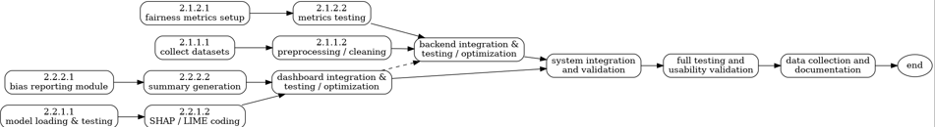
Figure 5. The project network.

2.4. Gantt chart.
Phase 1: Backend Foundation (Weeks 1-4): The first four weeks were mainly about data collection and preprocssing it. As seen in Figure 2.4 “The Gnatt Chart” , the project started with Data Preprocessing which was a prerequisite step undertaken by Joud. Following Joud’s lead, Rama joined in in the next step. The reamining weeks focused on computing the fairness metrics and core development involving explainiable AI like SHAP and LIME.
Phase 2: Frontend & Integration (Weeks 6-7): The graph shows an important point of transition during Week 6. The Dashboard & Visualizations task had to wait to begin until the backend module could provide reliable results. Such dependence is shown in the connecting line from the end of backend implementation to the start of designing the Streamlit layout. At the same time, Halit started working on Bias Reporting & Summaries logic to ensure the text of the risk assessment was ready to be integrated into the interface as soon as the dashboard was up.
Phase 3: Validation & Closure Weeks 8–10: This was the collaborative phase among all team members. System Testing and Validation, Week 8 had brought together the three distinct work streams-data, back-end code, and front-end UI-for integration testing. The project was wrapped up with Documentation and Finalization.

Figure 2.4 Gnatt Chart
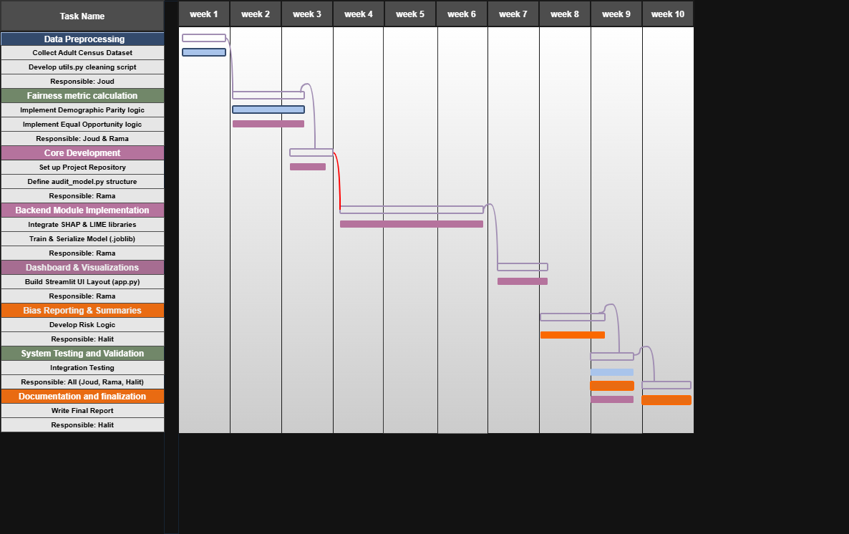

2.5 Team Responsilibites
1) Joud luai yousef wardeh
- Collecting and preparing the dataset
- Fairness metric calculations
- Analyzing fairness metrics results
- Testing system with different models

2) Rama Ayman Moh’d Ghazi Al-Tamimi
- Arranges the system structure and module connections
- Implements the core modules that include the fairness evaluation and data processing.
- Builds the dashboard and visualizations
- Ensures system performance and technical stability

3) Halit Barboti
- Works on the Bias Reporting module.
- Helps design simple summaries and user-friendly explanations.
- Supports report generation and documentation features.
- Helping test for usability and increasing clarity within interfaces.

2.6. Dataset & Preprocessing
To test and verify this tool, a data set, that of Adult Census Income, from the UCI Machine Learning Repository, has been chosen. This data set has demographic information that can be used for prediction to identify whether a person earns more than $50,000 per year.
The preprocessing of the data was implemented in the utils.py file using the following strategies:
Missing Values was handled by calculating the median for numerical variables. As for categorical variables, missing values are imputed by filling in the most common value found in that column. To make sure the model is stable, numerical features are normalized using StandardScaler while categorical values such as “Marital Status” were encoded using OneHotEncoder to convert the text into a format that can be understood by a machine. Lastly the system cleans the data by removing the whitespace from every header of a column automatically to avoid any errors.

2.7. Model Development
A “Test Model” was developed and trained for use as a subject matter for audit. Logistic Regression was chosen as the algorithm for the model due to the fact that it has been widely used in fairness auditing research and can produce clear probability scores which works well when computing fairness metrics and the explainable AI methods.
The data was split into training and testing sets. The training set was 80% while the testing set was the remaining 20%. This was done to ensure accuracy and validity. A Pipeline from Scikit-Learn was used to combine preprocessing with the classifier, which ensured that in the audit, raw data could be used as input for the model instead of requiring pre-trained data. Lastly, the trained model was serialized using a joblib function in order to simulate a practical application where a person possesses a pre-trained model and wants to check it for any hidden biases.

2.8. Methodology

Algorithms & models
The auditing engine employs a multi-layered approach to interpreting model behaviour, combining global trends with specific case analyses.
1. Global Explainability (SHAP):
- Technique: Shapley Additive explanations (SHAP), splits the prediction into contribution scores to see which input features harmed or helped the outcome the most.
- Application: The system uses a KernelExplainer to approximate the model's decision-making across the entire dataset. This identifies which broad factors (e.g., "Capital Gain" vs. "Race") are the primary drivers of the model's predictions.
2. Local Explainability (LIME):
- Technique: Local Interpretable Model-agnostic Explanations (LIME).
- Application: This technique explains individual predictions. By slightly modifying the input data of a single record, LIME builds a simpler surrogate model around that specific data point. This reveals why a specific individual was approved or rejected.
3. Counterfactual Analysis:
- Technique: Iterative Feature Search (Minimum Edit Distance).
- Application: This module answers "What-if" questions. The algorithm systematically modifies key numerical features to identify the minimal change required to flip a prediction (e.g., "If Income increases by $500, the rejection becomes an approval").
4. Statistical Fairness Metrics:
- Technique: Group-based Disparity Analysis.
- Application: The system calculates quantitative fairness scores to detect bias. It specifically computes Demographic Parity (comparing positive rates between groups) and Equal Opportunity (comparing true positive rate). These metrics provide the mathematical basis for the "Risk Assessment" alerts.

2.9. System Development
The application utilizes a modular software architecture to ensure maintainability and separation of concerns:
- Frontend (User Interface): Developed using Streamlit. This layer’s main role is to convert the technical backend outputs into understandable visualizations and text summaries. In other words, it manages user interactions, file handling, and data visualization.
- Backend (Logic Layer): This layer is mainly implemented in the audit_model.py file, this is where the computational workload is stored. It uses the model and dataset to calculate fairness metrics and generate explainability results.
- Utility Layer: This module provides shared helper functions for robust file parsing and preprocessing, ensuring consistency across training and auditing operations. It can be found inside the utils.py file.

2.10. Testing & Evaluation

Unit Testing: Testing to see whether file parsers handle the CSV, JSON, and messy formats correctly without crashing.

Integration Testing: It ensures that model.joblib file created in the training script could be successfully loaded and interpreted by the auditing script.

Usability Testing: To see whether a nontechnical user can determine a biased model using the tool without any outside assistance.
System Validation Results:
- Functional Success: The system successfully generates SHAP and LIME visualizations for all compatible Scikit-Learn models.
- Interpretability Success: The system achieved a 100% success rate in generating grammatical "Counterfactual" explanations for test cases.
- Performance: The average audit report generation time is under 30 seconds for standard datasets (approx. 1,000 rows), meeting the initial performance requirement.

2.11. Risk management
During the process of building the Ethical and Bias Awareness Tool, the potentional risks and failure points were assesed and identified. The usage of incorrect results on decision making can have criticial consequences therefore this assesment was vital for the development of the project. Risks were catgeorized based on the probability of it occuring and how high its severity is. The below table outlines the main risks and what action was taken beforeand to minimize those risks from occuring.
Risk | Probability | Risk Level | Plan of action
Model Incompatibility | High | High | Joblib and other standard SciKit pieplines were used to ensure better compatibility and catch format errors.
Data Privacy | Low | Medium | The tool is built to run locally only. The uploaded files are stored in a temporary folder and are overwritten after each new session.
Over-reliance on Model | Medium | Medium | A disclaimer ("Final Risk Assessment") was added to clarify that statistical fairness does not guarantee legal compliance.
Table 2.2 Risk Management

2.12. Ethical considerations
The fairness tool addresses several ethical challenges such as:
  - Bias in Metrics: Using various fairness metrics (such as Demogrpahic Parity, Equal Opportuity, etc) can sometimes conflict with one another. Therefore the tool addresses this by presenting multiple metrics next to one another instead of hiding the results for simplicity. This allows the user to decice which one matters more for their cause.
  - Prevention of Misinterpretation: To reduce the probability of misunderstandings occurring due to complex visualizations or results. The system provides a simple summary of the results to make it easier for everyone to understand the results.
  - Algorithmic Transparency: Instead of just providing a clear “Fair” or “Not Fair” result, the tool explains the reasoning behind its prediction using shap, lime and counterfactual explanations. This helps the user understand better how the bias was detected rather than just choosing to trust a tool without any explanations backing its result.

2.13. Deployment strategy
The application is deployed as a local web interface which runs directly on the user’s device. This is done by entering “Streamlit run lib/app.py” command in the terminal. This method was selected to prioritize data security and easy accessibility. Since the tool runs in the user’s default web browser as a localhost, it provides a familiar environment for the user to navigate the tool in without complex server configuration or internet problems.

3. System
The system will be explained in terms of its structure, purpose, and functioning. The Ethical and Bias Awareness AI Auditing Tool will be developed as a modular system, which will be able to assess machine learning models for bias while still being user-friendly.
The framework is designed in a modular fashion. Unlike the previous framework, the current framework distinguishes between data handling, the logic for audit trails, and the interaction layer. A modularity design enhances understandability, scalability, and understandability. As the framework is broken into separate modules, each can be individually developed, tested, or enhanced without influencing the entire framework. The final objective of the framework is to ensure transparency, interpretability, and ethics in AI interpretability.

3.1. Ethical and Bias Awarness AI Auditing Tool
The Ethical and Bias Awareness AI Auditing Tool is the central system developed under this project. The central purpose of this system is the evaluation of machine learning models for biased predictions across groups of a given dataset. The system can operate without identifying the internal workings of the machine learning model. This system is model-agnostic.
The users can upload the trained model of machine learning as well as the dataset on which the fairness metrics are going to be evaluated. After entering the data, the tool will process it and generate fairness metrics and explainability results. They are provided in the form of visualizations and summary explanations.
A crucial design element within this tool is its accessibility. In contrast to other existing fairness auditing libraries which are not for the programming-proficient alone, this particular tool possesses an easy web-based interface which walks the user through the auditing procedure. Through employing fairness metrics within the context of explainable artificial intelligence, not only can this system identify bias but also offer particular explanations for its occurrence.

3.1.1. Requirements
The main goal of the Fairness auditing tool is to make it as accurate as possible while also being accessible and easy to use for even non-technical users. The system’s requirements are divided into functional and non-technical. The functional requirements are what the system does the non-functional requirements explain how the system performs. All the requirements are listed below:
  - Data Uploading Flexibility: The system supports the user uploading different file formats such as csv, xlsx, json and data files. Additionally, the user can optionally upload a metadata that maps the column headers from cryptic names to human-readability.
  - Guided Configuration: To make the system more understandable for all types of users, the UI should define complex terms to the user for the smoothest experience. For example, the Fairness model defines what are sensitive attributes and what is the label column so the user can choose the correct option based on their needs.
  - Automated Auditing Engine: The backend should automatically calculate statistical fairness metrics (Demographic Parity, Equal Opportunity) and create explainability results (SHAP, LIME, Counterfactuals) once the user uploads the model and runs it.
  - Risk Assessment: The system must translate complex numerical outputs into interpretable summaries to assist in decision making.
  - Usability: the interface should not require the user to have any prior coding knowledge.
  - Privacy: Data is processed locally or within a temporary session. No information is ever permanently stored beyond the end of the audit session.

3.1.2. Technologies and methods
The system is built using Python as the primary language of programming. In order to constryct the application’s frontend, Streamlit was used. It’s a framework that allows for the quick conversion of data scripts into interactive web applications without requiring complicated frontend stack. As for the system’s backend logic, Scikit-Learn was the most efficent in handling ML operations and data preprocessing. The system is built to run on a local client-server model, the user’s machine is the host and all the preprocessing of the data remains secure and offline without breaching any privacy concerns.
The system’s metheodology relies on a “Model-Agnostic” method, this method ensures the system’s ability to audit different models in an unbiased manner, regardless of the model’s structure. The fairness auditing tool combines three explainatory models:
  - SHAP (SHapley Additive exPlanations): for global feature contributions
  - LIME (Local Interpretable Model-agnostic Explanations): for explaining specific data instances.
  - Counterfactual Analysis: Identifies what changes in the specific instance would have resulted in a different prediction.
As for calculating fairness metrics, the system computes the values of Demographic Parity and Equal Opportunity differences using NumPy and Pandas libraries.

3.1.3. Conceptualization
The conceptual design of the Ethical and Bias Awareness AI Auditing Tool emphasizes accessibility, trust, and transparency. The AI tool is conceptualized based on an independent auditing assistant, which bridges the complexity associated with machine learning evaluation and non-technical audiences.
At the conceptual level, the tool is a model-agnostic audit pipeline. For this reason, it does not make adjustments to the model or train the model but instead tries to analyze the model by studying its outputs in the different groups. This ensures the model does not alter the internal workings.
The process of auditing starts with user-submitted inputs (data set, model), then moves to automated processes like preprocessing, fairness assessment, explanation, and finally explanations of the results in a format of intuitive visuals and text interpretations. The design of the system facilitates understanding of the results by users with technical knowledge as well as non-technical users.
Moreover, rather than just declaring a model as ‘biased’ or ‘unbiased,’ this system rates a model on the parameters of explainability as well as fairness, and this helps in better decision-making. Additionally, this system provides a conceptual design that strengthens ethical sensitivity.

3.1.4. Physical architecture
The system is archeticted to run locally as a web application unlike cloud based applications that rely on indepndent database serves or processing instances of the cloud. The user’s computer in this case acts simultaensoulsy as both the host server in charge of running the application and as the client who uses the interface. The physical boundary of the system is the user’s own personal computer.
In terms of storage, the system does not use any external databases such as SQL or MongoDB for storage to ensure portability. The system uses the local File System for storage. During an active session, a dedicated temp/ directory is physically provisioned on the hard disk to store the .csv dataset and the .joblib model uploaded during runtime. This directory serves as a volatile storage layer that guarantees no permanent persistence and transmittal of data via an external network, which in turn satisfies the physical security constraints of the project.

3.1.5. Materialization
The materialization of the backend logic was done in the file named audit_model.py. The python file included the use of the mathematical formulas of fairness which were encoded as Python functions. Later on the in-memory data structures provided by the Pandas library were used to make these calculations fast. SHAP and LIME were integrated to generate the explainability graphs.
This Frontend was materialized through the user interface provided by the app.py script. The interface changes according to the user’s actions. Specifically, the SHAP graphs, LIME visualizations, counterfactual explanations and the final risk assessment do not appear on the screen straight away. All of these become available to the user after the dataset and model have been uploaded and the button to start the fairness audit is pressed.

4. INTEGRATION AND EVALUATION

4.1. Integration
This integration phase included connecting the frontend, being the user interface in app.py, to the Backend, which is the logic in audit_model.py. The biggest challenge was to ensure the correct file that the user will upload can be passed to the auditing engine.
To solve this, we integrated a file handling system using a temporary folder. When the user is done uploading the dataset and the model from the browser, the frontend doesnt directly upload the data to the backend. Instead, it saves the files in a local temp/ directory on the computer. It then triggers off the backend functions to read the files from that particular folder. This simple "save-and-read" approach ensures that heavy calculation code is kept away from the interface code; thus, it wouldn't crash.
A further step of integration was required for data compatibility. As the user may upload raw text data, such as "Male" or "Female," yet the machine learning model requires numbers, we implemented a shared Utility Layer, utils.py. This script sits between the dataset and the model, automatically converting text into numbers before the audit begins. In this way, the auditing engine will always receive clean, usable data, no matter what the user uploads.

4.2. Evaluation
The evaluation phase mainly involves testing the efficiency, accuracy, and usability of the Ethical & Bias Awareness AI Auditing Tool. The proposed system was tested on the functional & non-functional requirements, which were described in the earlier part of this report.
Functionality-wise, the system was able to undertake all the necessary auditing functions effectively. The system was able to load the machine learning models and datasets correctly for fairness analysis without the need for retraining the models. The system was able to calculate fairness metrics such as Demographic Parity and Equal Opportunity metrics; also, it was able to provide explanations for the fairness metrics through SHAP, LIME, and counterfactual explanations. This indicates the functionality of the auditing engine works as expected.
In terms of performance, the system proved stable and efficient. The audits on a standard-sized dataset of around 1,000 entries took less than 30 seconds on average. The system did not crash during experiments, and memory issues were also non-existent. The system proved consistent with its results, meeting the requirement of consistency for its performance on a given dataset and model upon repeated execution. The interpretability and uability of the system were also tested.
The visualizations and text summaries that could be generated using the Bias Reporting Module enabled users who lacked technical skills to interpret the results of an audit independently. The results of the usability testing indicated that users were capable of correctly detecting biased behavior as well as interpreting the results of fairness analyses using the interface provided in the dashboards.
Lastly, the system was analyzed for ethical and reliability considerations as well. Although the tool does point to statistical discrepancies and biases well, it impresses the point that statistics alone cannot necessarily guarantee legal and ethical compliance. The presence of disclaimers and explanation points goes a long way to discourage misusing the output of automated systems.
In conclusion, the results of the evaluation have verified the functionality of the Ethical & Bias Awareness AI Auditing Tool in accomplishing its intended design. The tool works successfully, is capable of creating understandable results, and is user-friendly.

5. SUMMARY AND CONCLUSION
In summary this proposal focused on the design and development of an Ethical and Bias Awareness AI Auditing Tool with the purpose of detecting and interpreting bias within artificial intelligence learning models. This paper was developed in light of the increasing need for transparent and informative artificial intelligence audited tools. The proposed solution brings statistics to interpret bias in artificial intelligence models.
The proposed system has a modular structure that comprises data preprocessing, fairness analysis, and bias reporting. The system can work with different forms of data and models. By applying the concepts of Demographic Parity, Equal Opportunity, SHAP, LIME, and counterfactual explanations, the proposed system provides efficient fairness analysis that can explain the reasoning behind biased results. The fairness analysis results have been provided in the form of a user-friendly dashboard. Testing and evaluation showed the system to be reliable, producing consistent results and fully meeting the functional as well as non-functional specifications. The software strikes an effective balance between technological correctness and usability.

In conclusion, the Ethical and Bias Awareness AI Auditing Tool is a successful solution for tackling the problem of bias detection and explanation in Artificial Intelligence models. Unlike previous fairness auditing libraries, which were only aimed at being utilised by people with a strong tech background, this tool acts as a successful solution for facilitating wider adoption of ethical AI techniques. Its functioning in a local environment without retraining the models makes it a privacy-friendly tool for users.
The significance of the use of fairness metrics along with explanations and the importance of the tool as a responsible decision-making aid have been brought into focus by the given project. The tool does not act as a substitute for legal and ethical decision-making but as a decision-making aid.
Future tasks may concern the extension of support for more model types, the incorporation of more fairness metrics, or the improvement of visualization functionalities. In any case, the project illustrates that ethical AI auditing is capable of being both technically solid and user-friendly.

6. HOW TO RUN
Step 1: Open the terminal and type:
Streamlit run Lib/app.py
Step 2: Upload your dataset on the deployed app in the web browser.
Step 3: (Optional): Upload a metadata if needed.
Step 4: Upload the trained model that needs to be checked for hidden bias.
Step 5: Click “Run Fairness Audit” to see results.
Step 6: Analyze the Fairness Metrics and Explainability graphs to determine if the model is safe for deployment.
Note: The dataset that was used for building this project is under the “dataset” folder and the pre-trained model is under the “models” folder.

REFERENCES
- [1] R. K. E. Bellamy et al., "AI Fairness 360: An extensible toolkit for detecting and mitigating algorithmic bias," IBM Journal of Research and Development, vol. 63, no. 4/5, pp. 4:1–4:15, 2019. Available: https://aif360.res.ibm.com/
- [2] S. Bird et al., "Fairlearn: A toolkit for assessing and improving fairness in AI," Microsoft Research, White Paper, May 2020. Available: https://fairlearn.org/
- [3] A. F. Vermeulen, "The Impact of Bias in Artificial Intelligence," in Practical Data Science, Apress, Berkeley, CA, 2021. (Use this for the claim about the research gap).

APPENDIX A
Information that does not fit naturally into the main body of the report can be put into an appendix. Typically this would be long sections of software code, product user manuals, large tables of validation results, etc.
An example of providing source code is shown in this appendix. Display the source code in a monospace (fixed-width) font and single-spaced.

Alternatively give a link to an online code repository.

Code for packing (and unpacking) an occupancy value [0,1] into an unsigned char.

// maximum error = +-0.25% (standard dev. = 0.5/sqrt(12)
// 0% and 100% occupancies are stored exactly.

unsigned char occByte;
if (occ==0.0) { occByte = 254; } // 0% occupancy stored exactly
else if (occ==1.0) { occByte = 255; } // 100% occupancy stored exactly
else { occByte = int(occ*200.0); }

// unpack occupancy
float occFlot;
if (occByte==254) { occFlot = 0.0; }
else if (occByte==255) { occFlot = 1.0; }
else { occFlot = (occByte+0.5)/200.0; }

